How to run the vector based plugin

Before opening the plugin make sure that all the dataset that are needed to run it are loaded into your QGIS window. Make sure that all the datasets have the correct type. The datasets are the following:

Table 1. The datasets needed for the analysis. Their names are not important but the type is cruicial.

|  |  |
| --- | --- |
| Dataset | Type |
| Administrative boundaries | Polygon |
| Population | Polygon |
| GHI | Raster |
| Wind speed | Raster |
| Travel hours | Raster |
| Nighttime lights | Raster |
| Elevation | Raster |
| Land cover | Raster |
| Existing HV lines | Lines |
| Planned HV lines | Lines |
| Existing MV lines | Lines |
| Planned MV lines | Lines |
| Substations | Points |
| Transformers | Points |
| Roads | Lines |
| Hydropower | Points |

**NOTE: The name of the datasets are arbitrary.**

**NOTE2: When you have made sure that you have all the datasets needed loaded into QGIS please create an empty folder and name it after your country. This folder will serve as your workspace.**

**NOTE3: If you enter the wrong dataset in any of the boxes you might have to restart QGIS.**

**NOTE 4: In the current version of the plugin (as of March 2019) it is necessary to select a dataset in all boxes. If there are no data available for MV lines or transformers please reuse one of the existing datasets as placeholder and then replace these values with 0’s in the resulting CSV-file**

1. **Open** the plugin from the **Database** menu. The name of the plugin when installed will be **GEP OnSSET**
2. The following window will open up.

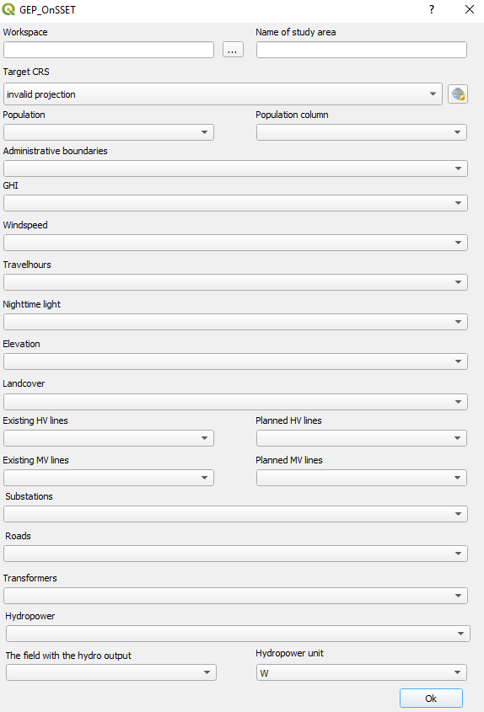

Figure 1. The plugin in use

Below information will follow regarding the use of each box

**Box 1**. This box lets you choose the workspace. Click on the three dots and navigate to the empty folder that you have created previously. When you have found it click ok and continue.

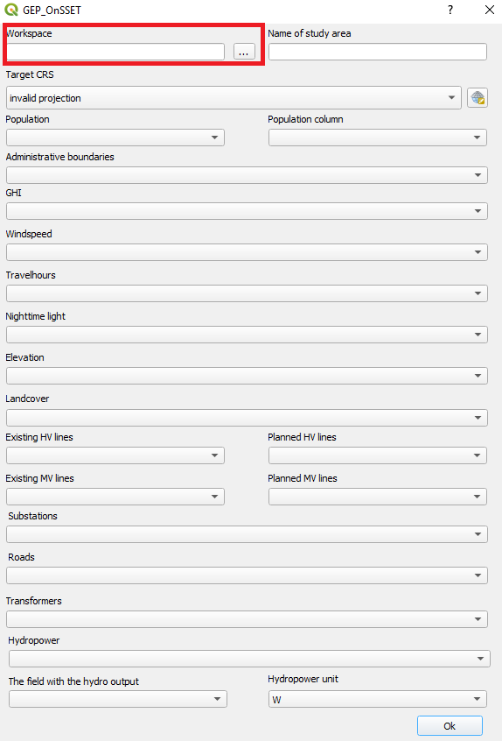

Figure 2. Box 1: enter the workspace by clicking on the button with three dots and navigate to the empty folder you are using as workspace

**Box 2**. Enter the name of your study area. This is the name will be given to your csv output file.

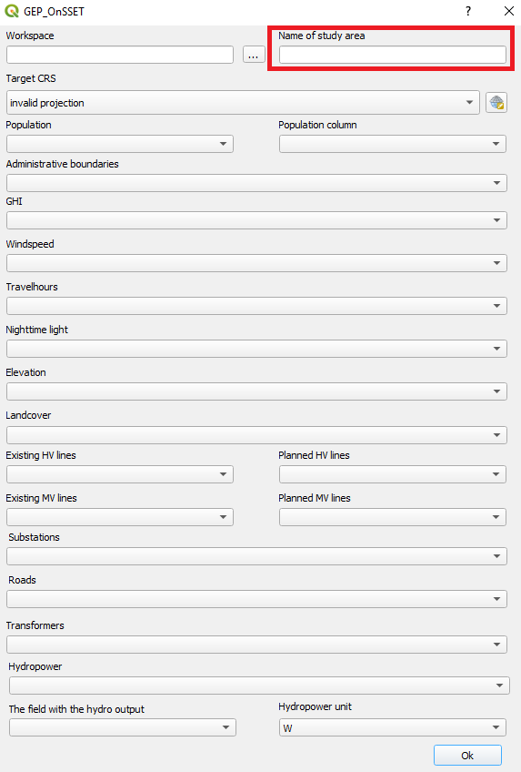

Figure 3. Box:2 Enter the name of the study area

**Box 3**. This box lets you choose an appropriate coordinate system.

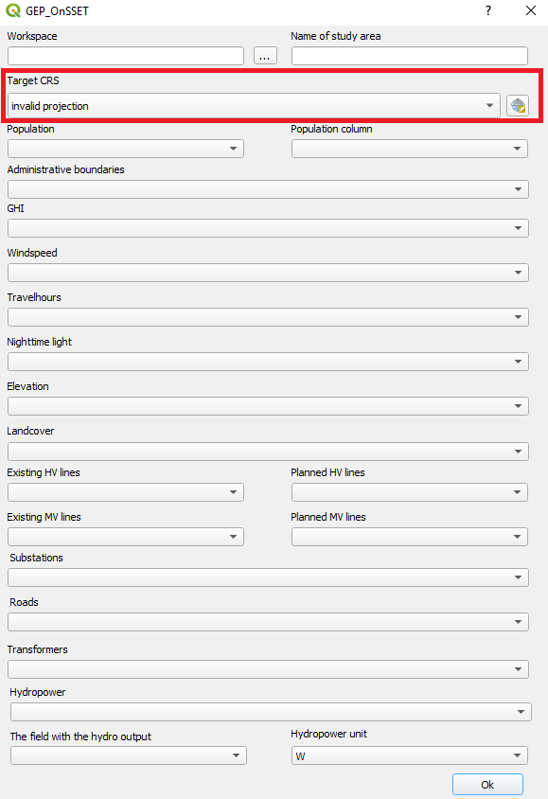

Figure 4. Box 3. Enter the coordinate system that you wish to reproject your data to

To find the coordinate system that is appropriate for your country please visit <http://epsg.io/> and search for your country.

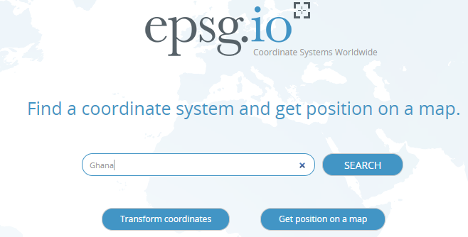

Figure 5. Go to epsg.io and search for the country you want to reproject

This will present you with a list of coordinate systems suitable for your study area.

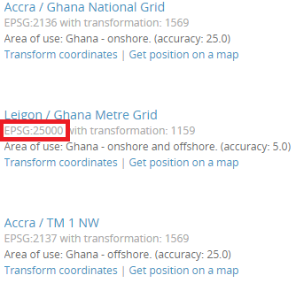

Figure 6. You will get a list of different coordunate systems that fit with your study area. Choose one and note its EPSG code.

Next, come back to QGIS. Click on the icon next to the field and check the EPSG code received from the webpage. Choose one where the unit is in meters and the red box covers the whole area you are working with.

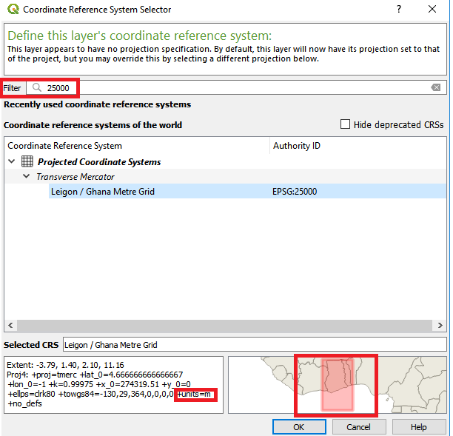

Figure 7. Enter the coordinate system you have chosen in the field. Make sure that the unit is meters (lower left box) and that the red area covers your study area (lower right box)

**Box 4 and 5**. In box 4 select the population dataset. You will have to choose the column that represents the population in the attribute table in box 5.

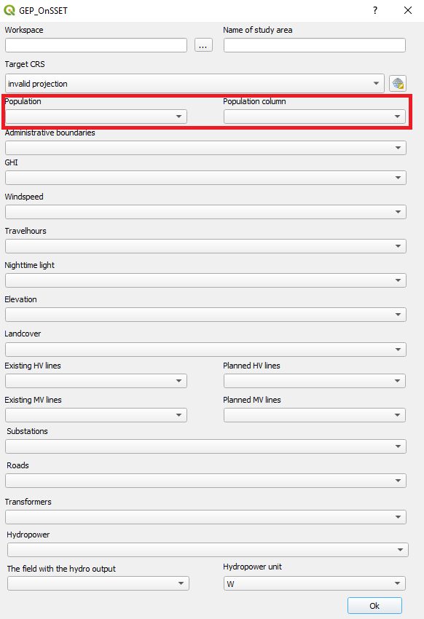

Figure 8. Box 4: enter the population clusters and in Box 5 select the column representing the population

**Box 6 – Box 19.** Select the correct datasets for the boxes

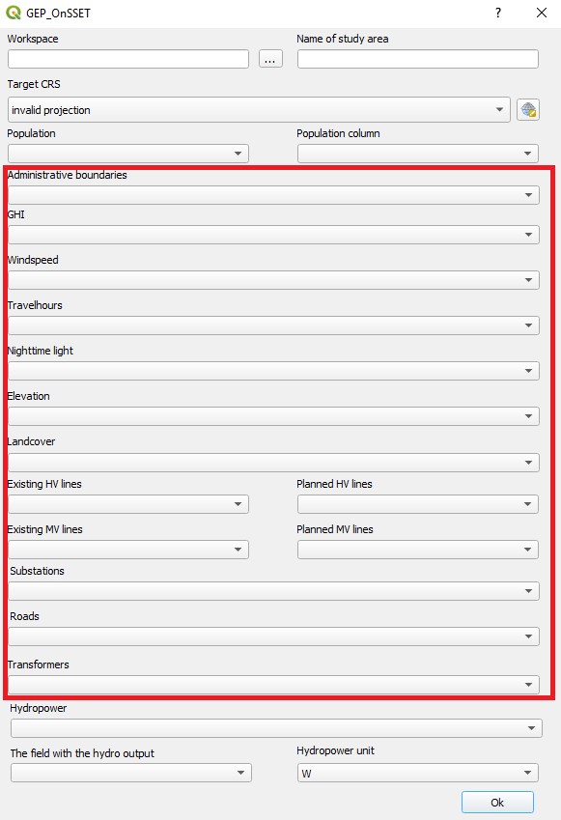

Figure 9. Fill in the correct datasets for each one of these boxes.

**Box 20.**  Click on the box and select the hydropower layer, make sure that it is a point vector.

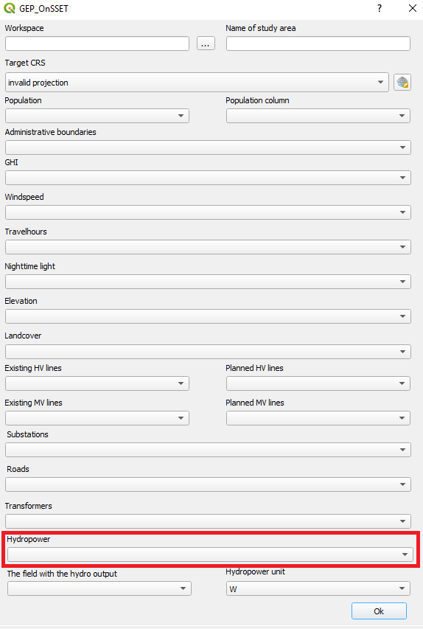

Figure 10. Hydropower points in this to be entered in this box

**Box 21.**  Select the box that includes the hydropower output (In this box you will select a column in the attribute table). The hydropower output is the potential electricity that can be outputted from each plant

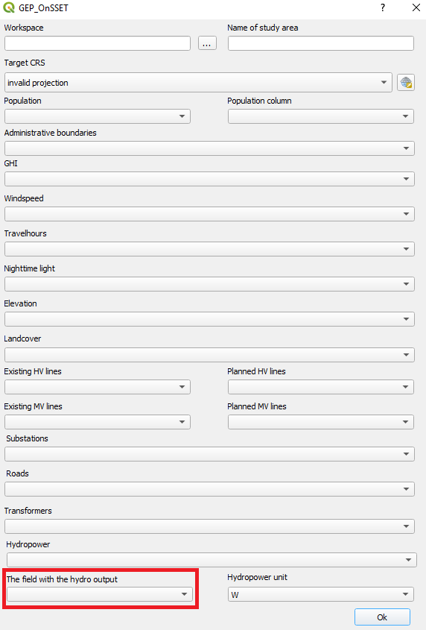

Figure 11. Field in the attribute table that includes the hydropower potential

**Box 22.**  Select the unit of that the hydropower output is given in. You get to choose between W, kW and MW.

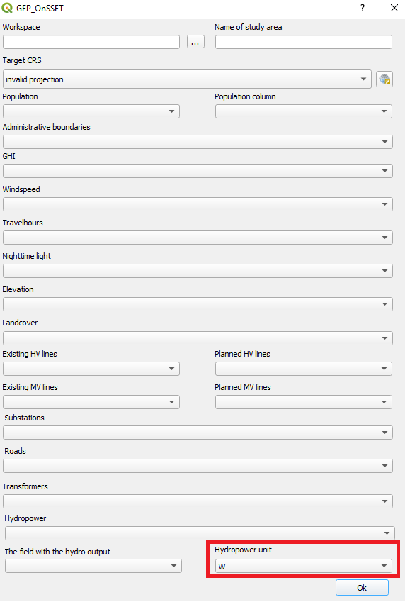

Figure 12. The unit of the values in Box 18

1. When all boxes have the correct data click “OK”. This will run the plugin. Depending on the size of the country this can take between 5 minutes and a number of hours.

When all the datasets are selected click “OK” to run the plugin

**NOTE5: While the plugin is running you will not be able to use QGIS. If you try to use QGIS you will get a loading icon. When the loading icon disappears the process is finished.**

1. When the plugin has finished a CSV file with the same name as you specified in box 2 will appear in a folder named “Assist” in your workspace folder.